AAW Z SERIES UNIVERSAL - AUAG LAUNCH EDITION  Z05 AuAg  Launch Edition  Z05 AuAg is the small universal you reach for when the playlist keeps changing. It keeps the 10mm dynamic-driver punch, adds armature clarity, and lets TwinCore shift the mood without swapping IEMs.  Those who listen will find the way. | 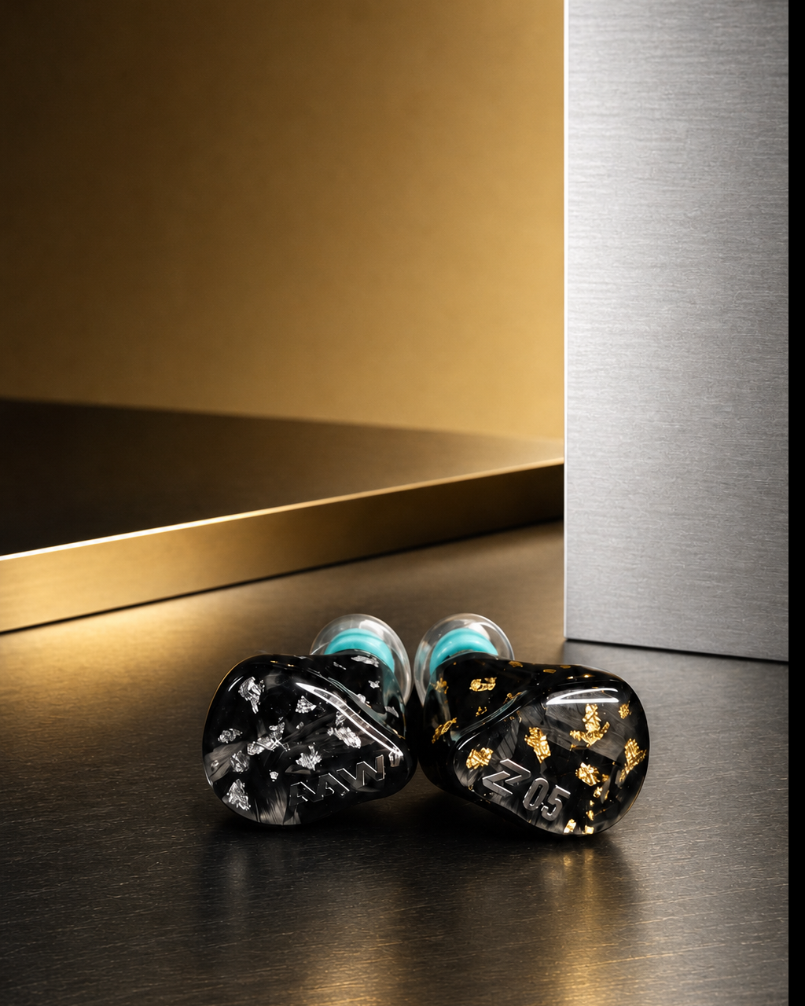
AT A GLANCE
The build behind the listen
Dynamic Bass  Kick drums and bass lines have real skin and pressure, not just a lifted low-end shelf. | Hybrid Detail  Armatures bring vocal edges, cymbal air, and room cues without thinning out the body. | AuAg Finish  Forged-carbon faceplates carry the gold/silver identity; the shells are finished by hand, pair by pair.

TWINCORE
Same monitor, two listening moods
Some albums want warmth and weight. Others ask for cleaner edges and a little more air. TwinCore lets Z05 AuAg move between those moods with a real switch on the shell, large enough to nudge by fingernail while the monitors stay in your ears.
No tool, no tiny recessed slot, no guessing through a phone app. The action has just enough resistance, only two positions, and is easy to find by touch once you know where it sits.
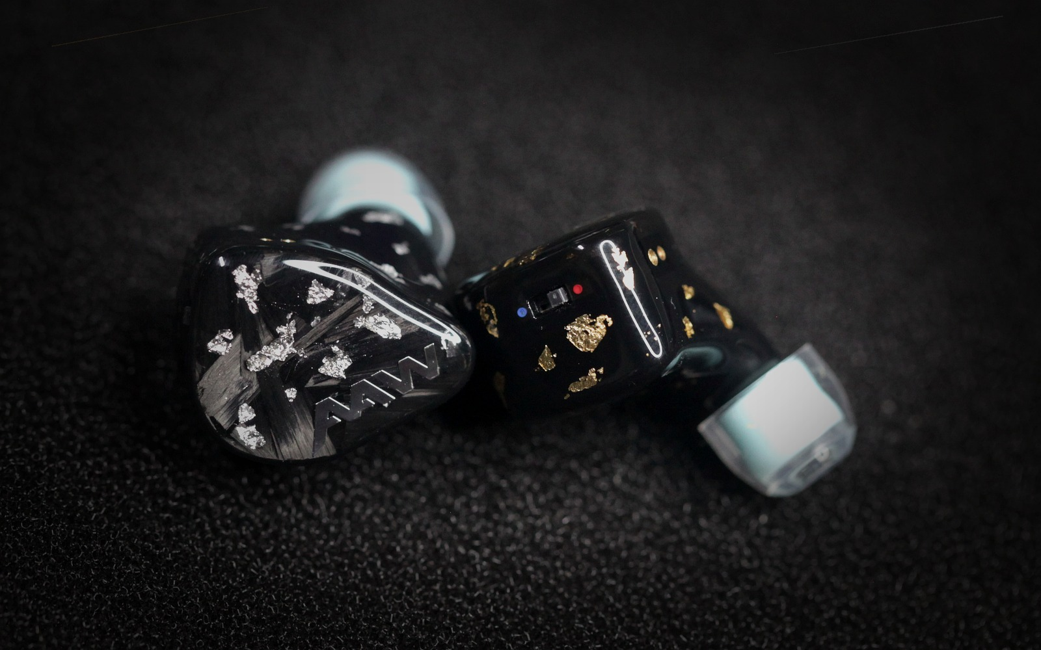
Blue Mode - Weight / Flow | A fuller low end, calmer upper harmonics, and a center image that feels easier to sit with for long albums.
Red Mode - Focus / Spark | Tighter bass outlines, more forward clarity, and extra cymbal air when you want the mix to open up.

OVERVIEW
A compact hybrid for people who rotate music
Some IEMs are tuned for one perfect demo track. Z05 AuAg is built for the way most of us listen: albums, playlists, dongles, DAPs, desk chains, and a mood that changes by the hour.

FITMENT
A universal fit that still feels settled
The best tuning falls apart if the shell keeps shifting. Z05 AuAg keeps the body compact, routes the cable over-ear, and lets the tip do the sealing work.
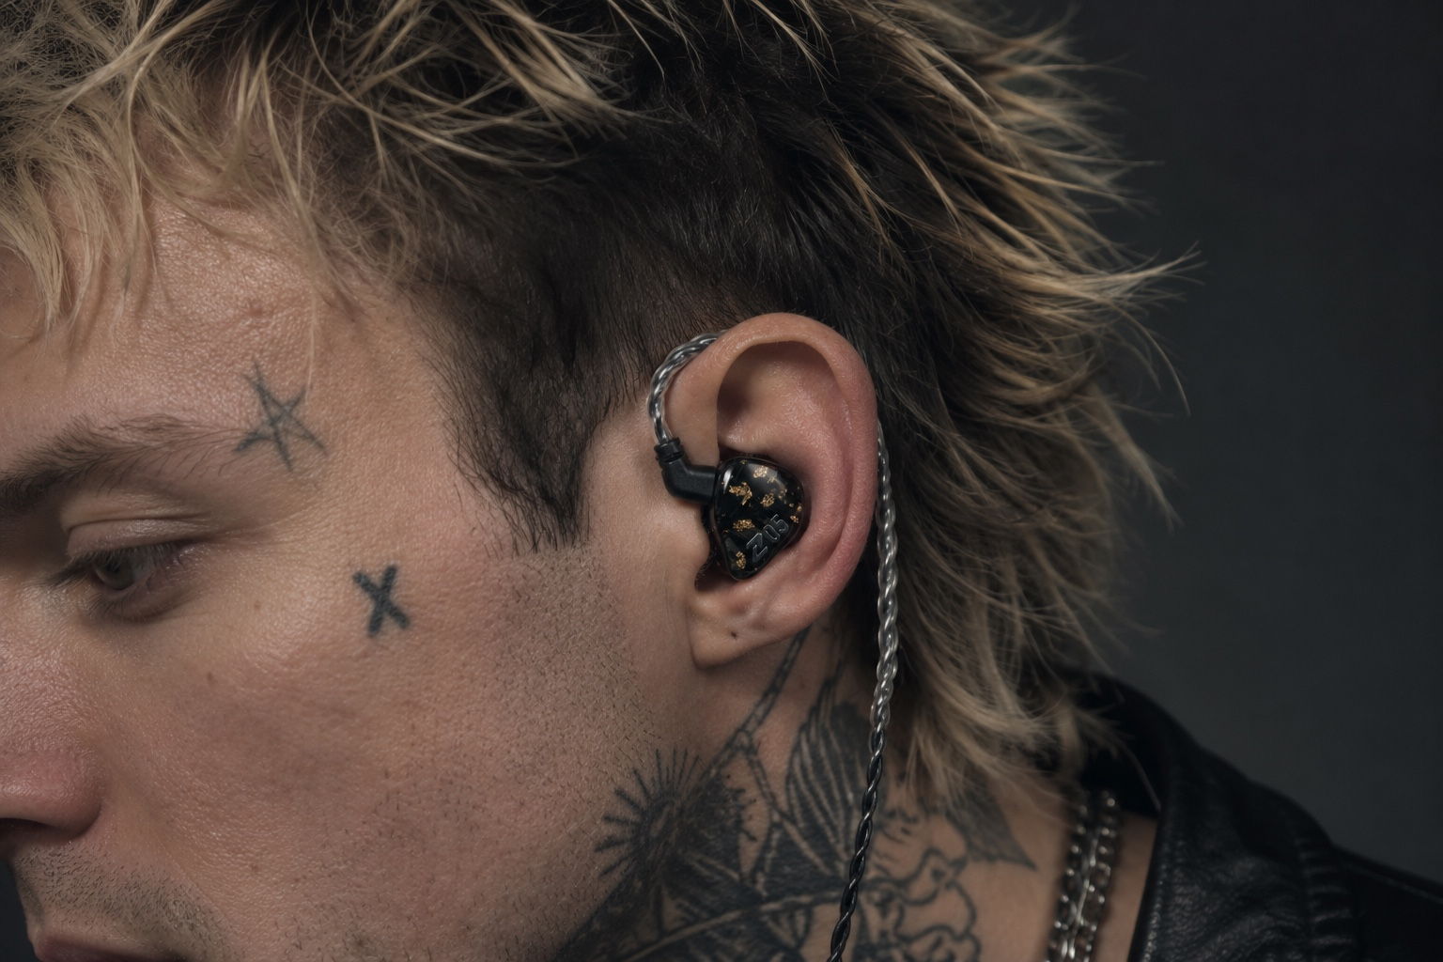
SIGNAL CHAIN READY
One cable, the sources most of us actually use
No one wants to buy a new cable on day one. Z05 AuAg ships with the paths that cover the usual rotation: phone, dongle, DAP, and desktop stack.
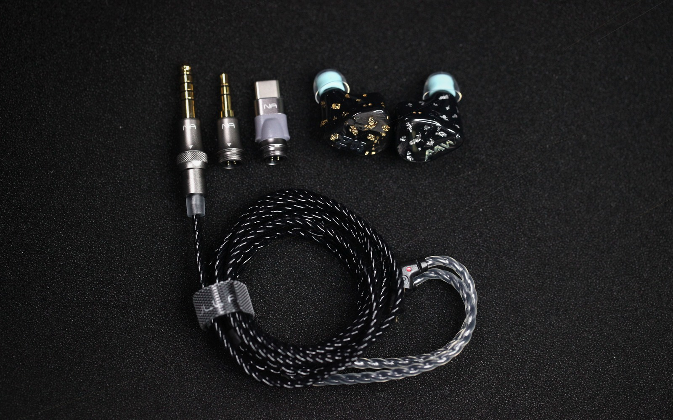
SEAL & COMFORT
The tip is part of the tuning
With a dynamic woofer, seal is not a footnote. When the tip sits right, bass weight, vocal center, and left-right balance stop changing every time you move.
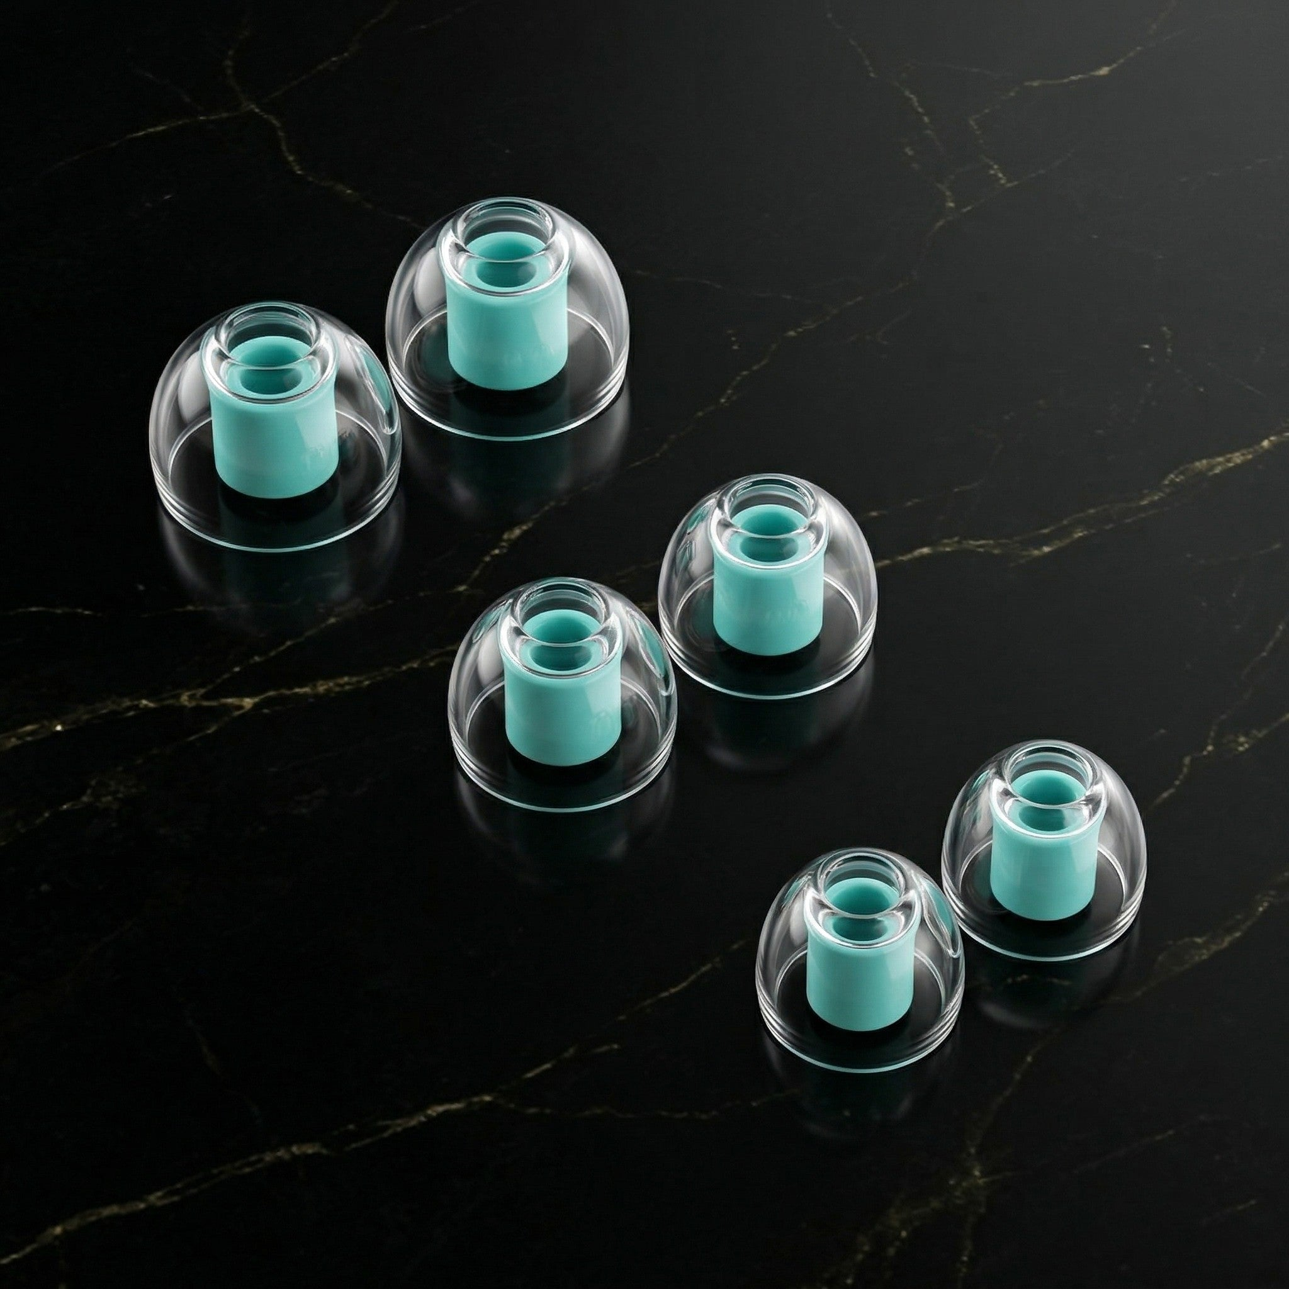

CRAFT & SOUND
Made to be worn, then looked at twice
The shell has to disappear before the finish gets to show off. Z05 AuAg starts with a compact universal fit, repeatable seal, and a driver layout that can stay convincing across long sessions.
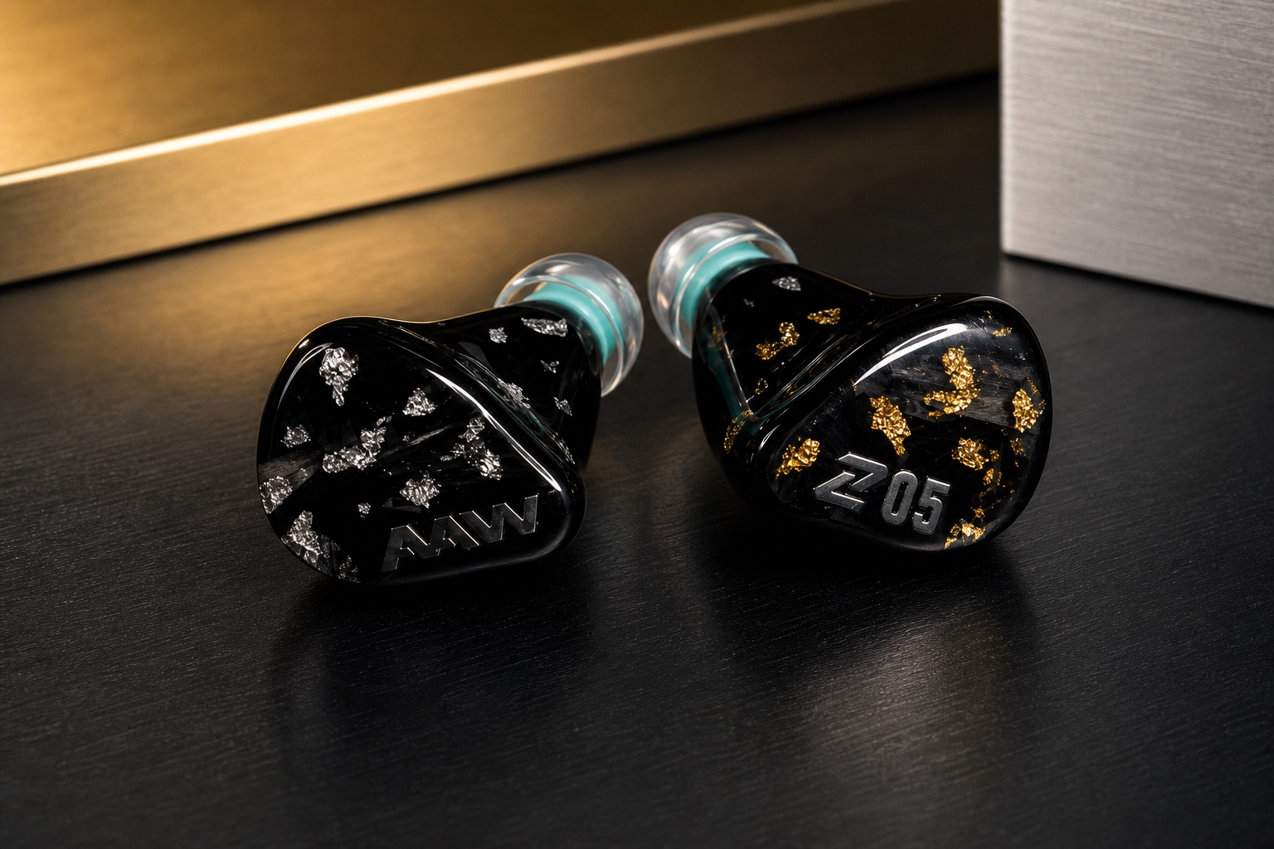
Format | Universal-fit hybrid in-ear monitor
Low End | 10mm PET diaphragm dynamic woofer
Clarity | Mid and super-high BA drivers for vocal edge and air
Voice Control | TwinCore physical voicing switch
Pressure Flow | Bass-Flow vent pressure system
Finish | Forged-carbon faceplates; 3D-printed shells with hand-laced gold and silver foil finish
In The Box | 2-pin detachable cable, 3.5mm, 4.4mm balanced, Type-C terminations, carrying case, LiquidMorph eartips

FAQ
A few notes before you hit play
What does AuAg mean?
Au is gold, Ag is silver. On this launch edition, the identity is split left/right: gold and silver accents over the hand-finished shell work, with forged-carbon faceplates doing the visual heavy lifting.

Is this only a cosmetic edition?
No. The finish gets attention first, but the reason to stay is the Z05 platform: dynamic bass, BA clarity, Bass-Flow pressure control, and TwinCore voicing.

What does the TwinCore switch change?
It changes the overall voicing. Blue leans fuller and easier; red leans cleaner and more awake. It feels broader than a simple bass bump.

What cable is included?
Z05 AuAg includes a 2-pin detachable cable, 3.5mm stereo, 4.4mm balanced, and Type-C terminations, plus LiquidMorph tips so you can get the seal right from the first session.

Choose the mood, keep the groove.
Those who listen will find the way.
A launch-edition Z05 with real low-end body, armature detail, and a physical switch for the way your listening mood actually changes.

